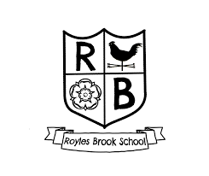

Children will retain knowledge that is pertinent to science with a real-life context.

Trips and visits from STEM Ambassadors ensure to enhance cultural capital.

Children develop their working scientifically skills in collaboration with peers.

Children receive opportunities to showcase their learning and develop their understanding when working outdoors in the school grounds and local area.

Children receive a fun, engaging and high-quality science education.



Working Scientifically skills and key vocabulary show clear progression within each phase.

Create assessment opportunity at the end of each topic for the children to showcase their learning and understanding.

Teachers foster an enjoyment of science in children in ensuring that lessons are practical, collaborative and ensure the children can be curious about the world around them.

Teachers feel more confident in developing the children’s scientific enquiry skills and embedding learning into long term memory.

There is a clear progression of knowledge and scientific skills.

Children work collaboratively to solve problems.

Children are curious and develop their scientific understanding through a practical enquiry-based approach.

Children build upon prior learning of knowledge and vocabulary within each phase.

A range of STEM Ambassadors and Scientists are weaved throughout the curriculum so children develop an understanding of the career pathways in science and how their learning relates to the wider world.

Children can use and apply the working scientifically skills.

Children use the local area and school grounds to develop their understanding.

We aim for children to become naturally curious and enquiry-based learners through developing their understanding using the working scientifically skills. Children work collaboratively through researching, investigating and evaluating their experiences. Children are encouraged to be inquisitive by using their senses to explore the world around them and ask lots of questions.

Impact

Implementation

Intent

Science

Subject Overview 2024/25 – Royles Brook Primary School

In Royles Brook…